

# Session 1

Assignment 1 Question

*Session 1: Assignment 1*

**Table of Contents**

## Introduction

1. Problem Statement
2. Output

### Introduction

This assignment will help you to consolidate the concepts learnt in the session.

1. **Problem Statement**

**Task 1:**

1.

Install Jupyter notebook and run the first program and share the screenshot of the output.

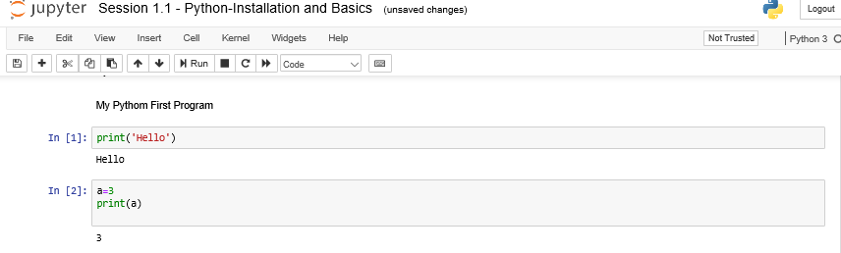

2.

Write a program which will find all such numbers which are divisible by 7 but are not a multiple of 5, between 2000 and 3200 (both included). The numbers obtained should be printed in a comma-separated sequence on a single line.

#program

num=list(range(2000,3201))

for i in num:

if i%7==0 and i%5!=0:

print(i)

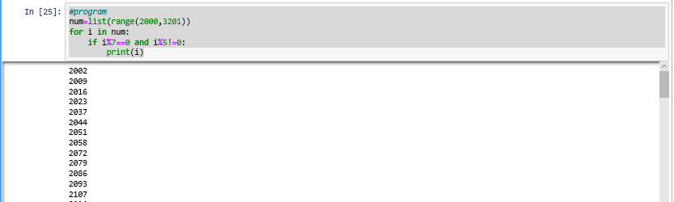

3.

Write a Python program to accept the user's first and last name and then getting them printed in the the reverse order with a space between first name and last name.

# Python code to reverse string

# Using For loop

First_Name=input("Enter your First Name ")

Last_Name=input("Enter Your Last Name ")

# Function

def reverse(s):

str=""

for i in s:

str=i+str

return str

print(reverse(First_Name)," ",end="")

print(reverse(Last_Name))

Out Put

Enter your First Name Siva

Enter Your Last Name Reddy

aviS yddeR

4.Write a Python program to find the volume of a sphere with diameter 12 cm. Formula: V=4/3 * π * r 3

Program :

diameter=12

radius=diameter/2

v=(4/3)*(22/7)*(radius*radius*radius)

print("volume of a spher is V =", v)

output :

volume of a spher is V = 905.142857142857

### Task 2:

1.

Write a program which accepts a sequence of comma-separated numbers from console and generate a list.

values=input(" Please enter comma separated numbers ")

list=values.split(",")

print("List is ",list)

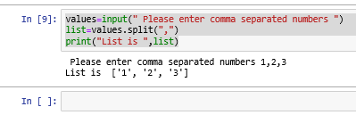

2.

Create the below pattern using nested for loop in Python.

*

* *

* * *

* * * *

* * * * *

* * * *

* * *

* *

*

Code :

rows = input("Enter max star to be display on single line= ")

rows = int (rows)

for i in range (0, rows):

for j in range(0, i + 1):

print("*", end=' ')

print("\r")

for i in range (rows, 0, -1):

for j in range(0, i -1):

print("*", end=' ')

print("\r")

Out Put :

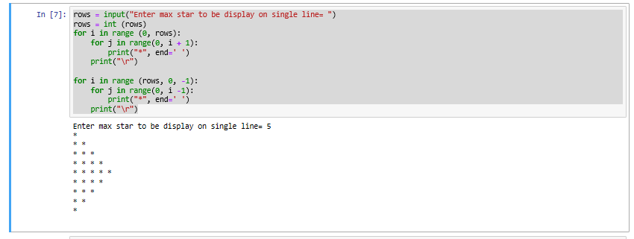

3.

Write a Python program to reverse a word after accepting the input from the user.

word=input("Please enter any word ")

def reverse(s):

str=""

for i in s:

str=i+str

return str

print(reverse(word))

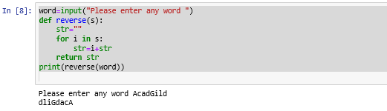

**Sample Output:** Input word: AcadGild Output: dilGdacA

4.

Write a Python Program to print the given string in the format specified in the **sample output.**

WE, THE PEOPLE OF INDIA, having solemnly resolved to constitute India into a SOVEREIGN, SOCIALIST, SECULAR, DEMOCRATIC REPUBLIC and to secure to all

its citizens

**Sample Output:**

WE, THE PEOPLE OF INDIA,

having solemnly resolved to constitute India into a SOVEREIGN, !

SOCIALIST, SECULAR, DEMOCRATIC REPUBLIC

and to secure to all its citizens

Code :

print("WE, THE PEOPLE OF INDIA,\n" )

print("\t having solemnly resolved to constitute India into a SOVEREIGN, !\n")

print("\t\t SOCIALIST, SECULAR, DEMOCRATIC REPUBLIC \n")

print("\t\t and to secure to all its citizens")

Output :

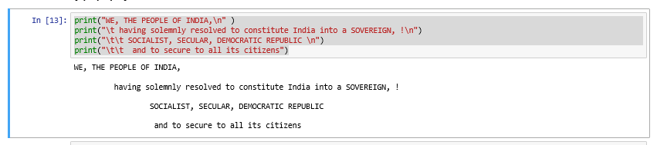

**NOTE: The solution shared through Github should contain the source code used and the screenshot of the output.**

1. **Output**

N/A